REPORT

CRYTOCURRENCY PRICE TRACKER USING PYTHON

Name: M.Monika

College: Vivekanandha College of Arts And Science for Women(Autonomous)

Team: Team 1

Mode Of Delivery: Individual

Batch: CN-TT Project Intern 25-Mar(B3)

Mode:Online

1. INTRODUCTION
Cryptocurrency is a digital form of currency that uses blockchain technology for secure transactions. Cryptocurrencies such as Bitcoin, Ethereum, Solana, Cardano and XRP have prices that change continuously according to market conditions.
The Cryptocurrency Price Tracker is a Python-based mini project developed to obtain the latest cryptocurrency pries from the CoinGecko API. The application displays the current price, 24-hour price change, 24-hour highest price and 24-hour lowest price.
The system automatically updates the cryptocurrency information at regular intervals. This makes it easier for users to monitor multiple cryptocurrencies from a single application.
The project demonstrates the use of Python programming, REST API, JSON data, HTTP requests and real-time data processing.

2. ABSTRACT
The Cryptocurrency Price Tracker is a Python application designed to monitor cryptocurrency market information in a simple and user-friendly way.
The system uses the CoinGecko API to retrieve real-time cryptocurrency information. The application tracks Bitcoin, Ethereum, Solana, Cardano and XRP. For each cryptocurrency, it displays the current price, 24-hour percentage change, highest price and lowest price.
The Python requests library is used to communicate with the API, while JSON data received from the API is processed and displayed in the VS Code terminal.
The application automatically refreshes the information every 60 seconds. This project provides a simple example of how APIs and Python can be used to develop a real-time data tracking application.

3. PROJECT DESCRIPTION
The Cryptocurrency Price Tracker is a console-based Python application.

The application follows these basic steps:
- Start the Python program.
- Connect to the CoinGecko API.
- Request cryptocurrency market information.
- Receive the data in JSON format.
- Extract the required information.
- Display the cryptocurrency details.
- Wait for 60 seconds.
Fetch the latest information again.

The project tracks the following cryptocurrencies:
- Bitcoin (BTC)
- Ethereum (ETH)
- Solana (SOL)
- Cardano (ADA)
- XRP

The system displays:
- Current price
- 24-hour percentage change
- 24-hour high price
- 24-hour low price
- Update time

4. OBJECTIVES

The main objectives of the Cryptocurrency Price Tracker are:
- To develop a simple cryptocurrency monitoring application using Python.
- To obtain real-time cryptocurrency data using an API.
- To display the current cryptocurrency price.
- To display the 24-hour price change.
- To display the 24-hour highest and lowest prices.
- To automatically update cryptocurrency information.
- To understand API communication using Python.
- To understand JSON data processing.
- To handle errors while retrieving data from the internet.
- To provide a simple tool for monitoring multiple cryptocurrencies.

5. TECHNOLOGIES USED

5.1 Python
Python is the main programming language used to develop the project. It is simple, readable and provides many libraries for working with APIs and data.

5.2 CoinGecko API
CoinGecko provides cryptocurrency market information through an API. The project uses the API to retrieve cryptocurrency prices and market information.

5.3 Requests
The Python requests library is used to send HTTP requests to the CoinGecko API.
Example:
response = requests.get(URL, params=params, timeout=10)

5.4 JSON
The API returns information in JSON format. Python processes this information and extracts the required values.

5.5 VS Code
Visual Studio Code is used to write, execute and test the Python program.

6.METHODOLOGY / WORKING
The working process of the system can be represented as:
START
↓
Python Application
↓
CoinGecko API
↓
Request Cryptocurrency
Information
↓
Receive JSON Data
↓
Process API Data
↓
┌─────────────────────────┐
│ Current Price │
│ 24h Change │
│ 24h High │
│ 24h Low │
└─────────────────────────┘
↓
Display Output
↓
Wait 60 Seconds
↓
Update Again

7. OUTCOMES
The project successfully achieves the following outcomes:
- Successfully retrieves cryptocurrency information from an online API.
- Displays the current prices of multiple cryptocurrencies.
- Displays 24-hour price changes.
- Displays 24-hour high and low prices.
- Automatically updates the information.
- Handles API/network errors.
- Provides practical experience with Python API integration.
- Demonstrates real-time data processing.

8. IMPLEMENTATION / SOURCE CODE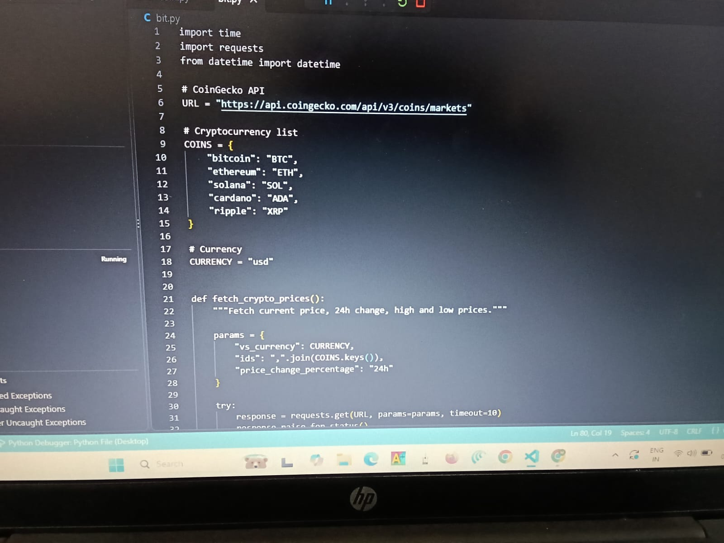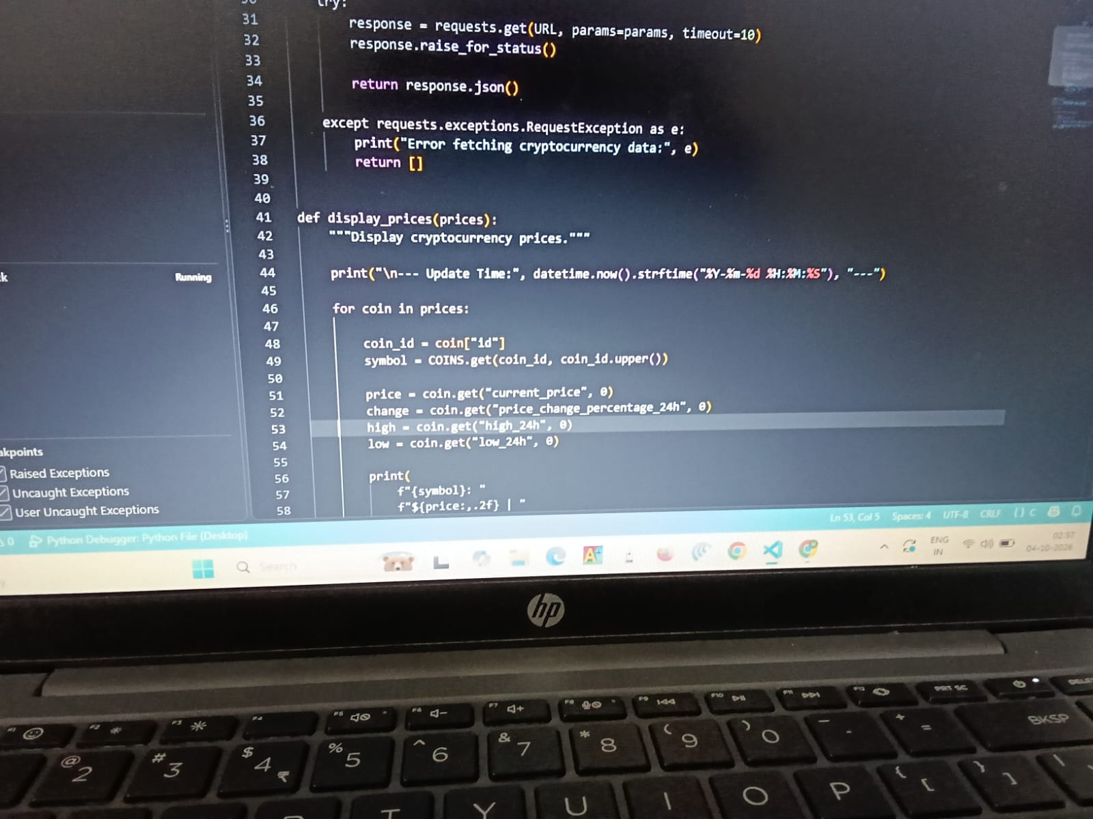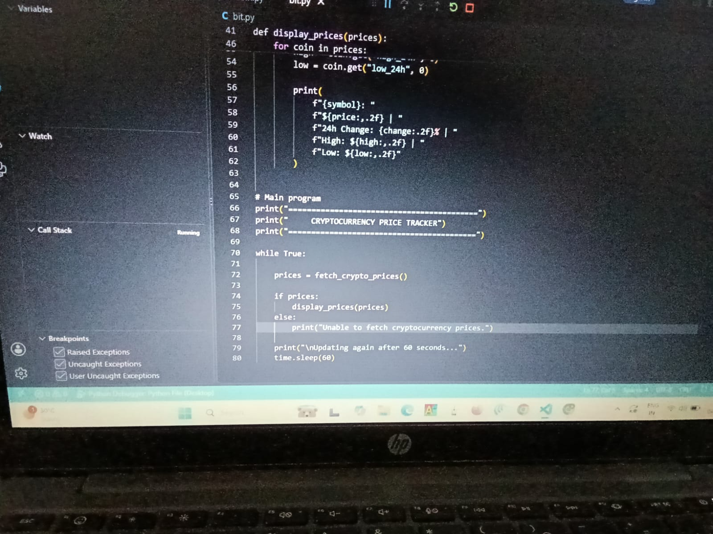9.OUTPUT: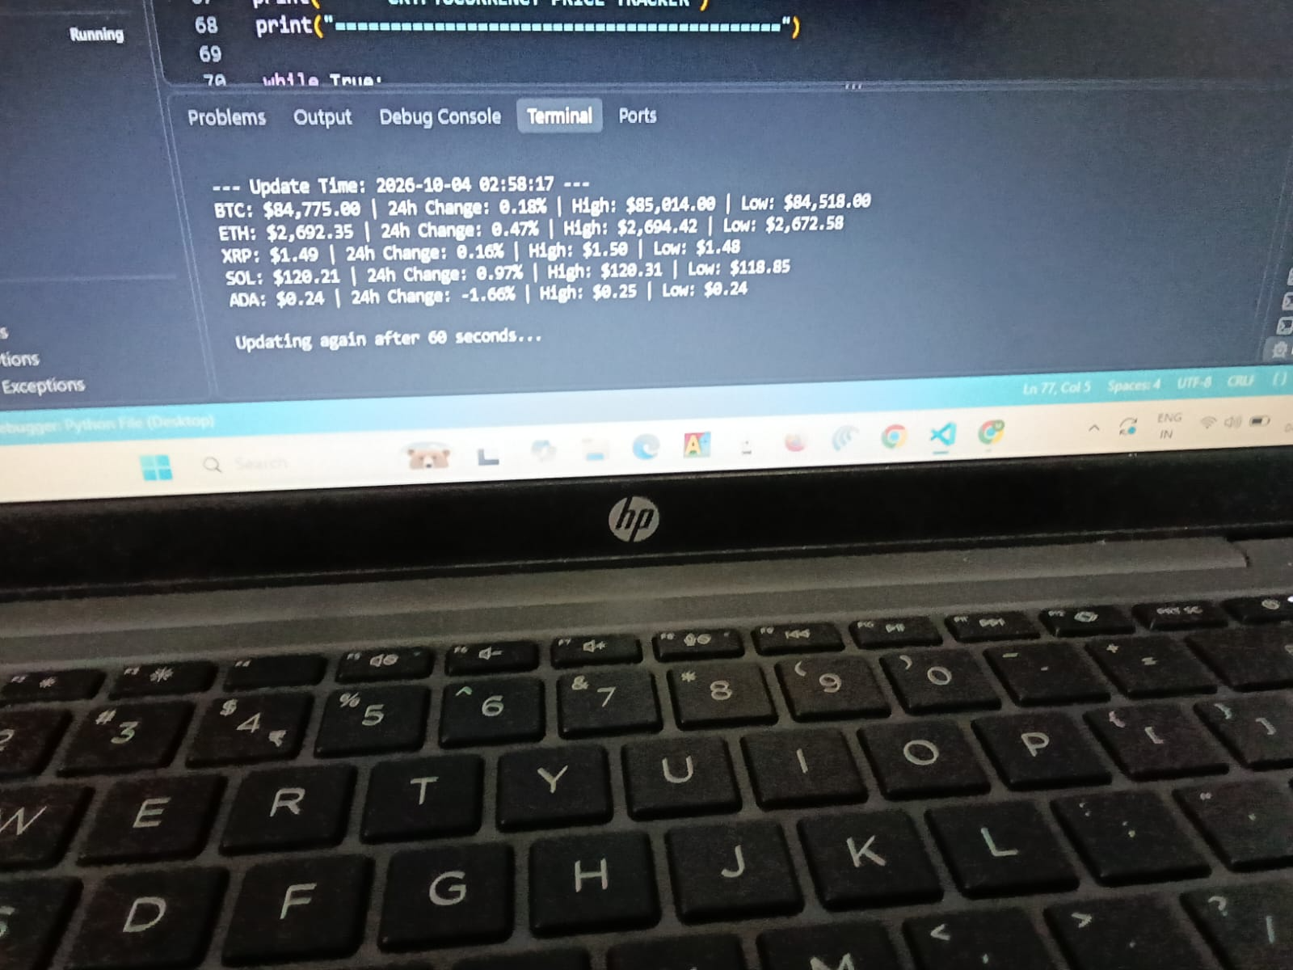

RESULTS
The Cryptocurrency Price Tracker successfully retrieved and displayed cryptocurrency market information using the CoinGecko API.
The application was able to display information for Bitcoin, Ethereum, Solana, Cardano and XRP.
The system successfully displayed the:
- Current price
- 24-hour change
- 24-hour high
- 24-hour low
- Update time
The automatic update mechanism also allowed the application to obtain updated information at regular intervals.
Therefore, the project meets its main objective of developing a simple cryptocurrency price monitoring system using Python.

TESTING:
Testing is performed to check whether the application works correctly

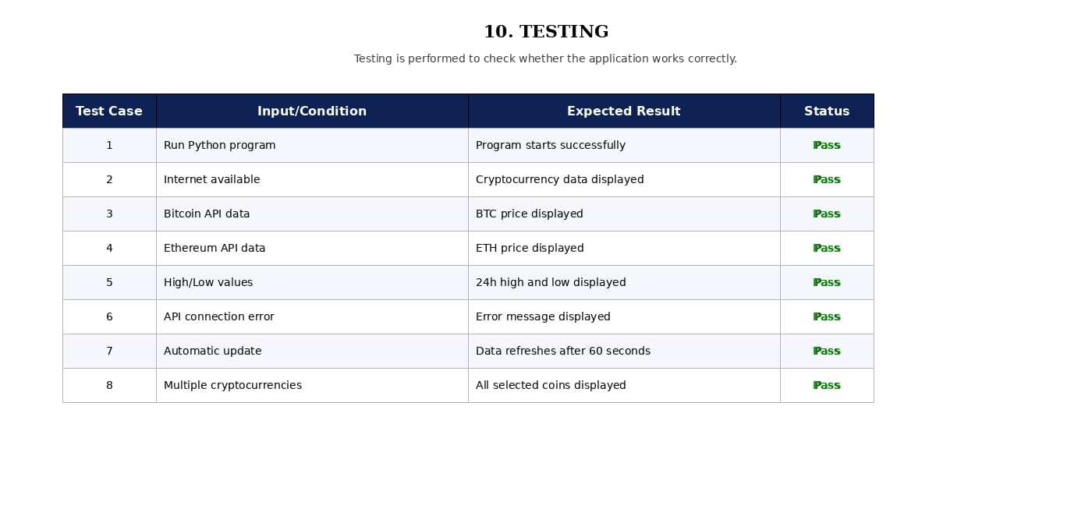

FUTURE DEVELOPMENT
The project can be improved in several ways.
1. Graphical User Interface
A GUI can be developed using Tkinter, PyQt or another Python framework.
2. Price Charts
Historical cryptocurrency prices can be displayed using graphs and charts.
3. Database
A database such as SQLite can be used to store cryptocurrency price history.
4. Web Application
The project can be converted into a web application using Flask or Streamlit.
5. Price Alerts
Users can receive an alert when a cryptocurrency reaches a particular price.
6. More Cryptocurrencies
More cryptocurrencies can be added to the tracker.
7. Mobile Application
The project can be extended into a mobile application.
8. Machine Learning
Machine learning techniques can be added to analyze historical data and predict possible price trends. Such predictions should be treated as estimates rather than guaranteed future prices.

CONCLUSION
The Cryptocurrency Price Tracker Using Python is a simple and useful mini project that demonstrates how Python can be used to retrieve and process real-time information from an external API.
The project successfully retrieves cryptocurrency data from the CoinGecko API and displays the current price, 24-hour percentage change, high price and low price for selected cryptocurrencies.
The project also demonstrates important programming concepts such as functions, dictionaries, loops, exception handling, API requests, JSON processing and automatic data updating.

